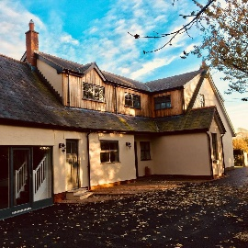

Restaurants
The Bay Horse serves top quality food and more on the pricey side but worth a trip - 01524 791204

The New Holly also called Michaelangelo’s decent prices and food good…. apparently - 01524 793500

Pipers is a small restaurant with nice food - 01524 606665

The Cartford Inn in Great Eccleston is very quirky and the new up and coming place to eat in Lancashire (may be exaggerating a little :) 15 minutes away - 01995 670166

Farmers Arms is very close to the Cartford Inn - food is okay but not as good as Cartford Inn but pleasant interior - 01995672018

Pubs and Eating
Elletson Arms – OMG our fav – please try, we don’t think you’ll be disappointed – everything is freshly cooked to order so expect a little wait 01253 790333

Patten Arms is a good busy place with reasonably priced and tasty pub grub and it’s only 1 minute away and has sky sports and BT (bonus ). We highly recommend this pub (again be careful if you choose to walk there). It’s also pet friendly - 01524 791484

Manor Inn pub is based in Cockerham 5 mins away – nice for a drink but not had the food in a long time (being honest) - 01524 791252

Mill at Condor Green is 15 mins away and is a pleasant restaurant/pub overlooking the canal – worth a visit for the roast beef on its own, it’s just delish and you can walk it off after on the canal 01524 752852

The Stork near the Mill – 01524 751234

The Plough at Galgate is 5 mins up the road going to Galgate – nice friendly staff and okay pub food – also has sky sports which is always a bonus 01524 751337

The Fleece at Dolphinholme is 10 mins away. Dog friendly. 01524 791233

Garstang based pubs are 10 mins away (below) - The Royal Oak 01995603318
Wheatsheaf – has sky sports and we think best pub in Garstang. Dog friendly. 01995 600486
Th’Owd Tithe Barn is oldi worldi and overlooking the canal 01995 604486
Guy’s Thatched Hamlet is pet friendly and based at Billsborrow which is 15 mins away and is near the canal and sometimes has children’s activities 01995 640010

